1. **User**

**User Signup**

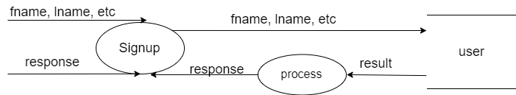

Level 2 User Signup

**User login**

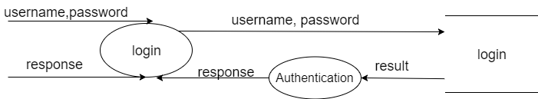

Level 2 User Login

**User Choose Subscription**

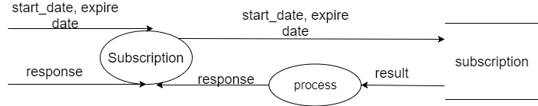

Level 2 User Subscription

**User Place Order**

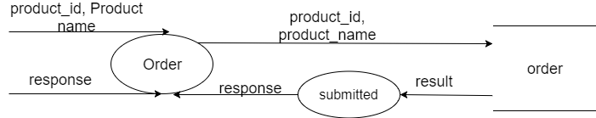

Level 2 User Order

1. **Admin**

**Admin login**

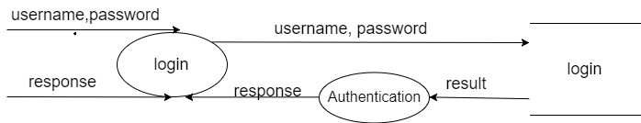

Level 2 Admin Login

**Admin Manage Order**

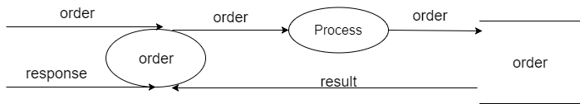

Level 2 Admin Manage Order

**Admin Update Status**

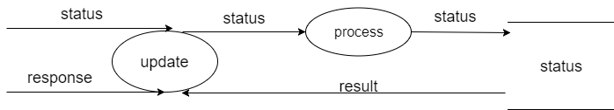

Level 2 Admin update Status